Project Report

K-Means Clustering: Image Segmentation

Name: Revanth Kalluri
Course: AI & ML (Batch-5)
Problem Statement: Use K-Means to implement Image Segmentation.

Prerequisites:
Software used and how I installed them:
Python 3.6: Download and install anaconda using https://www.anaconda.com/download/. After installing anaconda, install below modules(packages), using anaconda prompt to run the commands.
Module | Command
numpy | pip install numpy
matplotlib | pip install matplotlib

Pip is a package manager for python packages. Run “pip --version” in anaconda prompt to verify if pip is already installed. Run “conda install pip” to install pip for the first time.

Dataset used:
Image containing variety of fruits.

Method used:
K-Means Algorithm.

1. Importing necessary modules:
2. Read image and store it in required format:
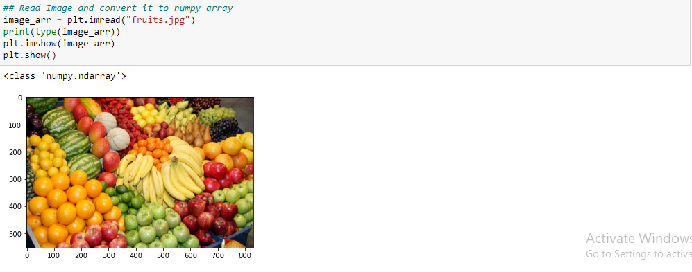
3. Randomly initialize labels for all Image pixels:
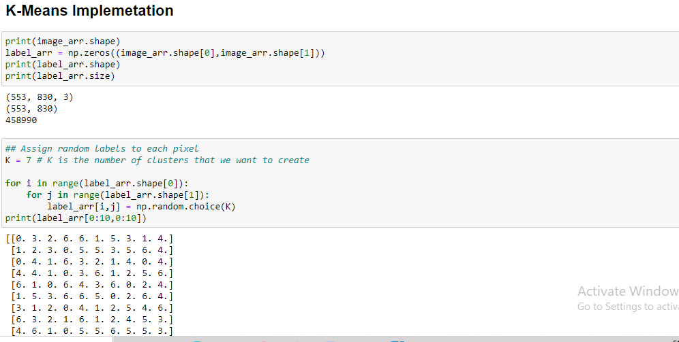
4. Function to calculate Euclidean distance between two vectors:
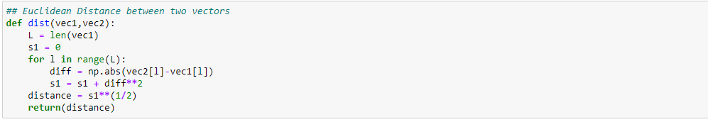
5. Define K-Means:
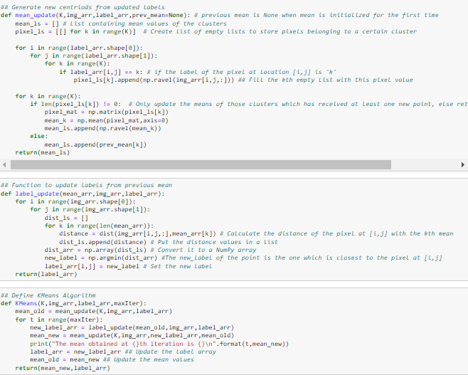

6. Implement KMeans and plot segmented image:
